**SE MODULE 4**

* **Introduction to SQL**
* Lab 1

Create database school_db;

CREATE TABLE students(

student_id int PRIMARY KEY AUTO_INCREMENT,

student_name varchar(40),

age int,

class varchar(40),

address varchar(40)

);

* Lab 2

INSERT INTO students (student_id,student_name,age,class,address) VALUES (1,’Aastha’,20,’12A’,'ghatlodiya');

INSERT INTO students (student_name,age,class,address) VALUES ('Jiyaa',20,'12A','Vastral'),('khushi',19,'12A','ghodasar'),('Kashish',20,'12B','Vastral'),('vishu',22,'12B','navrangpura');

SELECT * FROM students;

* **SQL Syntax**
  + Lab 1

SELECT student_name,age FROM students;

* + Lab 2

SELECT * FROM students WHERE age>10;

* **SQL Constraints**
  + Lab 1

CREATE TABLE teachers(

teacher_id int PRIMARY KEY AUTO_INCREMENT,

teacher_name varchar(40) NOT null,

subject varchar(40) NOT null,

email varchar(40) UNIQUE KEY

);

* + Lab 2

CREATE TABLE student(

sid int PRIMARY KEY AUTO_INCREMENT,

sname varchar(40),

rank int,

fid int,

FOREIGN KEY (fid) REFERENCES teachers(teacher_id)

);

* **Main SQL Commands and Sub-commands (DDL)**
  + Lab 1

CREATE TABLE courses(

course_id int PRIMARY KEY AUTO_INCREMENT,

course_name varchar(40),

course_credits int

);

* + Lab 2

CREATE DATABASE university_db;

* **ALTER Command**
  + Lab 1

ALTER TABLE courses ADD COLUMN course_duration int;

* + Lab 2

ALTER TABLE courses DROP COLUMN course_credits;

* **DROP Command**
  + Lab 1

DROP TABLE school_db.teachers;

* + Lab 2

DROP TABLE student;

* **Data Manipulation Language (DML)**
  + Lab 1

INSERT INTO courses (course_id,course_name,course_duration) VALUES (1,'BCA','3 year'),(2,'MSC IT','5 year'),(3,'Data Analytics','1 year'),(4,'BCOM','3 year'),(5,'Digital Marketing','6 month');

* + Lab 2

UPDATE courses SET course_duration='1 year' WHERE course_name='Digital Marketing';

* + Lab 3

DELETE FROM courses WHERE course_id=3;

* **Data Query Language (DQL)**
  + Lab 1

SELECT * FROM courses;

* + Lab 2

SELECT * FROM courses ORDER BY course_duration DESC;

* + Lab 3
* **Data Control Language (DCL)**
* **Transaction Control Language (TCL)**
* **SQL Joins**
  + Lab 1

CREATE TABLE department(

dept_id int PRIMARY KEY AUTO_INCREMENT,

dept_name varchar(40),

location varchar(40)

);

CREATE TABLE employee(

e_id int PRIMARY KEY AUTO_INCREMENT,

e_name varchar(40),

email varchar(40),

mobile bigint,

fid int,

FOREIGN KEY (fid) REFERENCES department(dept_id)

);

SELECT employee.e_id,employee.e_name,department.dept_name FROM employee INNER JOIN department ON employee.fid=department.dept_id;

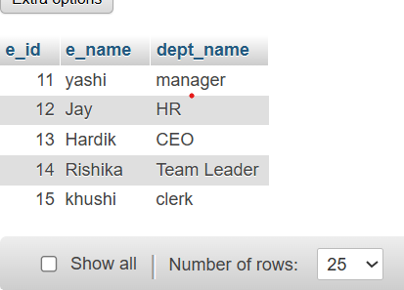

* + Lab 2

SELECT dept_id,dept_name,e_id,e_name FROM department LEFT JOIN employee ON department.dept_id=employee.fid;

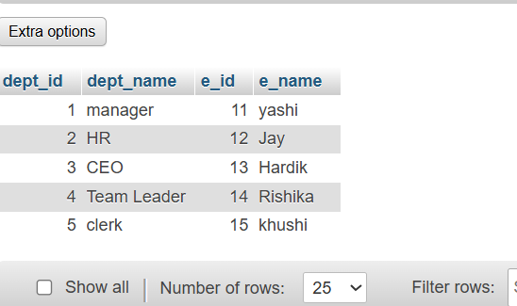

* **SQL Group By**
* **SQL Stored Procedure**
* **SQL View**
* **SQL Triggers**
* **Introduction to PL/SQL**
* **PL/SQL Control Structures**

**Extra**

* **Introduction to SQL**
  + Lab 3

CREATE DATABASE library_db ;

CREATE TABLE books(

book_id int PRIMARY KEY AUTO_INCREMENT,

title varchar(40),

author varchar(40),

publisher varchar(40),

year_of_publication year,

price bigint

);

INSERT INTO books (book_id,title,author,publisher,year_of_publication,price) VALUES (11,'Bhagvad Gita','Ved Vyas','gujrat sahitya prakash',-500,199),(12,'Ramayan','Valmiki','sanatan dharma prakash',-400,249),(13,'Ramcharitmanas','Tulsidas','gujrat sahitya prakash',2002,80),(14,'Durgha Saptashati','Maharshi Markandya','sanatan dharma prakash',1998,90),(15,'Shiv Mahapuran','Ved Vyas','sanatan dharma prakash',1996,180);

* + Lab 4

CREATE TABLE members(

member_id int PRIMARY KEY AUTO_INCREMENT,

member_name varchar(40),

date_of_membership date,

email varchar(40)

);

INSERT INTO members(member_id,member_name,date_of_membership,email) VALUES (21,'khushi','2025-06-25','k2@gmail.com'),(22,'maitri','2024-07-23','m4@gmail.com'),(23,'niyati','2023-06-25','n2@gmail.com'),(24,'pratham','2019-05-17','p5@gmail.com'),(25,'vivek','2018-06-25','v2@gmail.com');

* **SQL Syntax**
* Lab 3
* Lab 4

SELECT * FROM books WHERE author='ved vyas' ORDER BY year_of_publication DESC;

* SQL Constraints
* Lab 3
* Lab 4

ALTER TABLE members MODIFY email varchar(40) UNIQUE KEY;

* Main SQL Commands and Sub-commands (DDL)
* Lab 3

CREATE TABLE authorss(

author_id int PRIMARY KEY AUTO_INCREMENT,

first_name varchar(40),

last_name varchar(40),

country varchar(40)

);

* Lab 4

CREATE TABLE publishers(

publisher_id int PRIMARY KEY AUTO_INCREMENT,

publisher_name varchar(40),

contact_number bigint UNIQUE KEY,

address varchar(40)

);

* ALTER Command
* Lab 3

ALTER TABLE books ADD COLUMN genre varchar(40);

UPDATE books SET genre='spiritual' WHERE book_id=11;

UPDATE books SET genre='religious' WHERE book_id=12;

UPDATE books SET genre='spiritual' WHERE book_id=13;

UPDATE books SET genre='non-fictional' WHERE book_id=14;

UPDATE books SET genre='religious' WHERE book_id=15;

* Lab 4

ALTER TABLE members MODIFY email varchar(100);

* **DROP Command**
* Lab 3
* Lab 4
* **Data Manipulation Language (DML)**
* Lab 4

INSERT INTO authorss(author_id,first_name,last_name,country) VALUES (101,'Daivee','joshi','London'),(102,'Jiya','Prajapati','India'),(103,'Margi','Patel','London');

UPDATE authorss SET last_name='Barot' WHERE author_id=102;

* Lab 5

DELETE FROM books WHERE price>100;

* **UPDATE Command**
* Lab 3

UPDATE books SET year_of_publication='2016' WHERE book_id=13;

* Lab 4
* **DELETE command**
* Lab 3

DELETE FROM members WHERE date_of_membership < '2020-01-01';

* Lab 4

DELETE FROM books WHERE author IS NULL;

* **Data Query Language (DQL)**
* Lab 4
* Lab 5
* **Data Control Language (DCL)**
* **REVOKE Command**
* **Transaction Control Language (TCL)**
* **SQL Joins**
* Lab 3

SELECT books.title,authorss.first_name,authorss.last_name FROM books INNER JOIN authorss ON books.book_id=authorss.author_id;

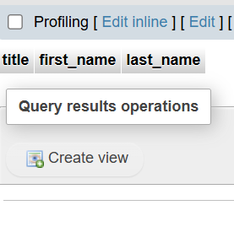

* Lab 4

SELECT title,publisher,first_name,last_name FROM books FULL JOIN authorss ON book_id=author_id;

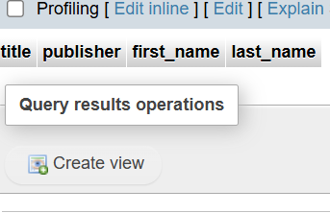

* **SQL Group By**
* **SQL Stored Procedure**
* **SQL View**
* **SQL Trigger**
* **Introduction to PL/SQL**
* **PL/SQL Syntax**
* **PL/SQL Control Structures**
* **SQL Cursors**
* **Rollback and Commit Savepoint**